# This is the correct output for the BST FIXME problem:

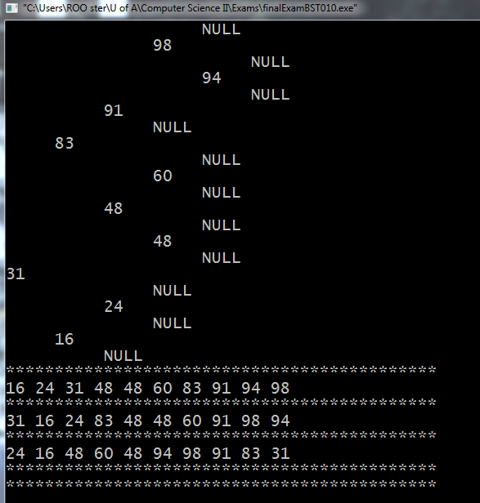

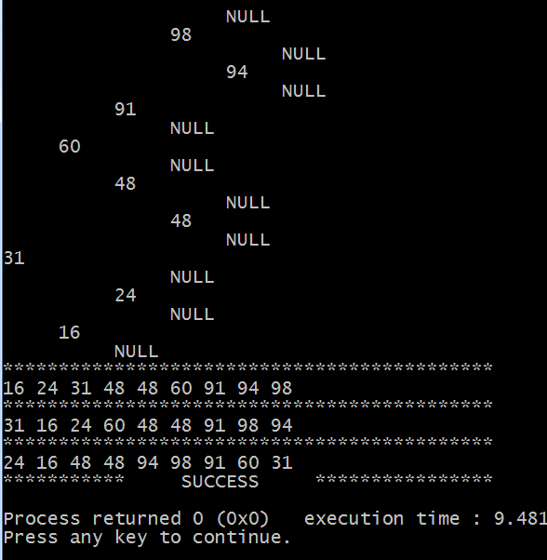

*Good luck! Remember to copy your debugged version back into the exam quiz answer box when finished.*